In the wake of the Sandy Hook school shootings, we’ve talked about gun laws and mental-health treatment, amid a host of other responses. But one potential tool has not been mentioned.
Now, let me say right off that I don’t pretend that nature is a paragon of peace. Writer Herman Melville once challenged the idea of nature as “the grand cure,” as he put it, and asked “who froze to death my teamster on the prairie?” The violence of nature is a fact, but this is also true: by assaulting nature, we raise the odds that we will assault each other. By bringing nature into our lives, we invite humility.
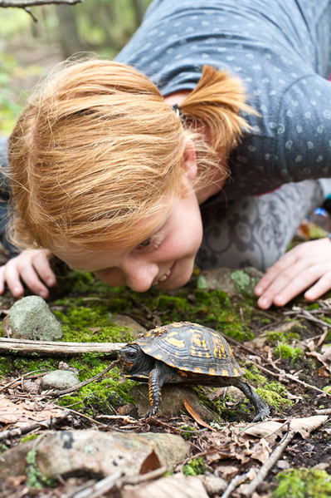
“In our studies, people with less access to nature show relatively poor attention or cognitive function, poor management of major life issues, poor impulse control,” says Frances Kuo, a professor at the University of Illinois, adding that humans living in a neighborhood stripped of nature undergo patterns of social, psychological, and physical breakdown similar to those observed in animals deprived of their natural habitat. “In animals, what you see is increased aggression, disrupted parenting patterns, and disrupted social hierarchies.”
On the other hand, in some settings the natural world does have the power to heal human hearts and prevent violence. That statement isn’t based on modern Romanticism, but on a growing body of mainly correlative scientific evidence, with a tight focus on the impact of nearby nature.
Here are six reasons why meaningful relationships with nature may — in concert with other approaches — bolster mental health and civility, and reduce human violence in our world.
1. Green exercise improves psychological health.
“There is growing . . . empirical evidence to show that exposure to nature brings substantial mental health benefits,” according to “Green Exercise and Green Care,” a report by researchers at the University of Essex. “Our findings suggest that priority should be given to developing the use of green exercise as a therapeutic intervention.” Among the benefits: improvement of psychological well-being; generation of physical health benefits by reducing blood pressure and burning calories; and the building of social networks.
2. In some cases, greening neighborhoods may help reduce domestic violence.
In a Chicago public housing development, researchers compared the lives of women living in apartment buildings with no greenery outside to those who lived in identical buildings—but with trees and greenery immediately outside. Those living near the trees exhibited fewer aggressive and violent acts against their partners. They have also shown that play areas in urban neighborhoods with more trees have fewer incidences of violence, possibly because the trees draw a higher proportion of responsible adults.
3. Natural playgrounds may decrease bullying.
In Sweden, Australia, Canada and the U.S., researchers have observed that when children played in an environment dominated by play structures rather than natural elements, they established their social hierarchy through physical competence; after an open grassy area was planted with shrubs, children engaged in more fantasy play, and their social standing became based less on physical abilities and more on language skills, creativity and inventiveness. Such play also provided greater opportunities for boys and girls to play together in egalitarian ways.
4. Other species help children develop empathy.
We’ve known for decades that children and the elderly are calmed when domestic pets are introduced in therapy, or included in rehabilitative or residential care. We also know that children can learn empathy by caring for pets. Some mental-health practitioners are taking the next step: using pets and natural environments as part of their therapy sessions. Cherie L. Spehar, a Licensed Clinical Social Worker and Play Therapist, who has served as executive director of The Child Abuse Prevention Center in Raleigh, N.C., recommends to therapists, “Bring nature play into your sessions, as it is a resource rich in opportunities for practicing kindness. Introduce them to every form of life and teach respect for it.”
5. Greater biodiversity in cities can increase social and family bonding.
Scientists at the University of Sheffield in the U.K. report that the more species that live in a park, the greater the psychological benefits to human beings. “Our research shows that maintaining biodiversity levels is important . . . not only for conservation, but also to enhance the quality of life for city residents,” said Richard Fuller of the Department of Animal and Plant Science at Sheffield.
In related work, researchers at the University of Rochester, in New York, report that exposure to the natural environment leads people to nurture close relationships with fellow human beings, to value community, and to be more generous with money. By contrast, the more intensely people in the study focused on “artificial elements,” the higher they rated wealth and fame. One of the researchers, Richard M. Ryan, noted, “[We’ve] found nature brings out more social feelings, more value for community and close relationships. People are more caring when they’re around nature.”
6. More nature in our lives can offset the dangerous psychological impact of climate change.
Professor Glenn Albrecht, director of the Institute of Sustainability and Technology Policy at Murdoch University in Australia, has coined a term specific to mental health: solastalgia, which he defines as “the pain experienced when there is recognition that the place where one resides and that one loves is under immediate assault.” Albrecht asks: Could people’s mental health be harmed by an array of shifts, including subtle changes of climate? If he’s right in suggesting this is so, and if climate change occurs at the rate that some scientists believe it will, and if human beings continue to crowd into de-natured cities, then solastalgia will, he believes, contribute to a quickening spiral of mental illness.
We are not powerless in the face of planetary or societal challenges. Granted, we will not be able to prevent every violent tragedy, but we can surely make our lives greener and gentler. And that positive influence may ripple outward in ways we cannot immediately measure or see.
“Simply getting people together, outside, working in a caring capacity with nature, perhaps even intergenerationally, may be as important as the healing of nature itself,” suggests Rick Kool, a professor in the School of Environment and Sustainability at Royal Roads University in Victoria, British Columbia. “Perhaps, in trying to ‘heal the world’ through restoration, we end up healing ourselves.”

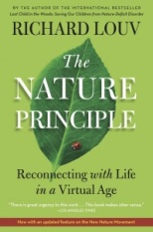Richard Louv is chairman emeritus of the Children & Nature Network and author of THE NATURE PRINCIPLE: Reconnecting With Life in a Virtual Age and LAST CHILD IN THE WOODS: Saving Our Children from Nature-Deficit Disorder, from which some of this essay is adapted.
Photo by Jon Beard

